PF Assignment 2

Name: Abdul Aziz

R No. 2430-0213

Date 1/15/2025

**Day 1**

#include <iostream>

int main() {

    double priceA = 50.0; // Price of Product A

    double priceB = 30.0; // Price of Product B

    double priceC = 20.0; // Price of Product C

    int quantityA, quantityB, quantityC;

    std::cout << "Enter the quantity of Product A: ";

    std::cin >> quantityA;

    std::cout << "Enter the quantity of Product B: ";

    std::cin >> quantityB;

    std::cout << "Enter the quantity of Product C: ";

    std::cin >> quantityC;

    double total = (priceA * quantityA) + (priceB  *quantityB) + (priceC * quantityC);

    std::cout << "Total cost: $" << total << std::endl;

    return 0;

}

Output

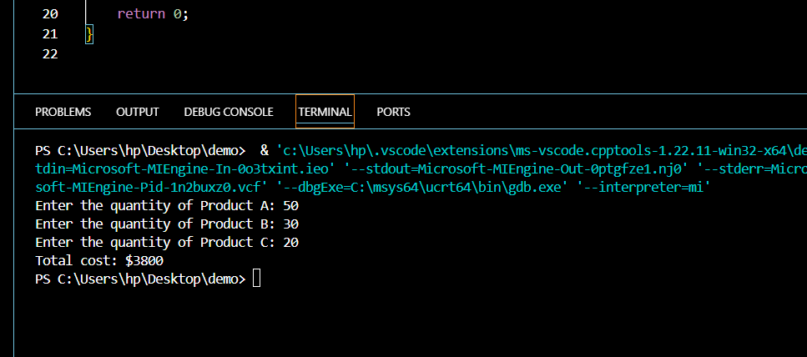

Day 2

include <iostream>

int main() {

    double priceA = 50.0, priceB = 30.0, priceC = 20.0;

    int quantityA, quantityB, quantityC;

    std::cout << "Enter the quantity of Product A: ";

    std::cin >> quantityA;

    std::cout << "Enter the quantity of Product B: ";

    std::cin >> quantityB;

    std::cout << "Enter the quantity of Product C: ";

    std::cin >> quantityC;

    double total = (priceA * quantityA) + (priceB * quantityB) + (priceC * quantityC);

    double finalTotal = (total > 200) ? total * 0.9 : total;

    std::cout << "Total after discount: $" << finalTotal << std::endl;

    return 0;

}

Out put

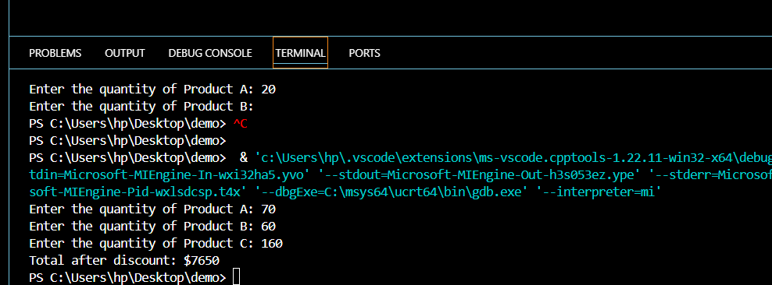

Day 3

#include <iostream>

int main() {

    double priceA = 50.0, priceB = 30.0, priceC = 20.0;

    int quantityA, quantityB, quantityC;

    std::cout << "Enter the quantity of Product A: ";

    std::cin >> quantityA;

    std::cout << "Enter the quantity of Product B: ";

    std::cin >> quantityB;

    std::cout << "Enter the quantity of Product C: ";

    std::cin >> quantityC;

    double total = (priceA * quantityA) + (priceB * quantityB) + (priceC * quantityC);

    double finalTotal = (total > 200) ? total * 0.9 : total;

    double shipping = (finalTotal < 150) ? 15.0 : 0.0;

    std::cout << "Total after discount and shipping: $" << finalTotal + shipping << std::endl;

    return 0;

}

Out put

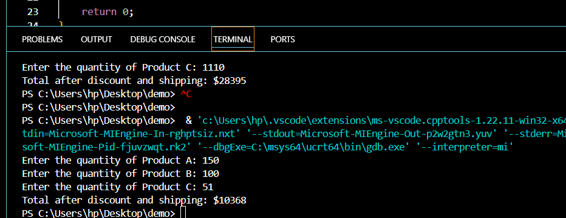

Day 4

#include <iostream>

int main() {

    double priceA = 50.0, priceB = 30.0, priceC = 20.0;

    int quantityA, quantityB, quantityC;

    std::cout << "Enter the quantity of Product A: ";

    std::cin >> quantityA;

    std::cout << "Enter the quantity of Product B: ";

    std::cin >> quantityB;

    std::cout << "Enter the quantity of Product C: ";

    std::cin >> quantityC;

    double total = (priceA * quantityA) + (priceB * quantityB) + (priceC * quantityC);

    double finalTotal = (total > 200) ? total * 0.9 : total;

    double shipping = (finalTotal < 150) ? 15.0 : 0.0;

    double totalWithShipping = finalTotal + shipping;

    int loyaltyPoints = (totalWithShipping > 300) ? 50 : 20;

    std::cout << "Total after discount and shipping: $" << totalWithShipping << std::endl;

    std::cout << "Loyalty points earned: " << loyaltyPoints << std::endl;

    return 0;

}

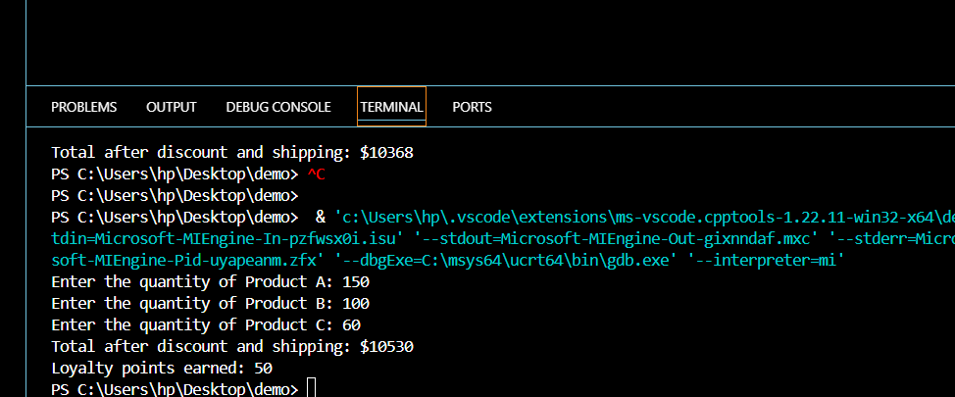

Day 5

#include <iostream>

int main() {

    double priceA = 50.0, priceB = 30.0, priceC = 20.0;

    int quantityA, quantityB, quantityC;

    std::cout << "Enter the quantity of Product A: ";

    std::cin >> quantityA;

    std::cout << "Enter the quantity of Product B: ";

    std::cin >> quantityB;

    std::cout << "Enter the quantity of Product C: ";

    std::cin >> quantityC;

    double total = (priceA * quantityA) + (priceB * quantityB) + (priceC * quantityC);

    double finalTotal = (total > 200) ? total * 0.9 : total;

    double shipping = (finalTotal < 150) ? 15.0 : 0.0;

    double totalWithShipping = finalTotal + shipping;

    int loyaltyPoints = (totalWithShipping > 300) ? 50 : 20;

    std::cout << "\nCheckout Summary:\n";

    std::cout << "-----------------\n";

    std::cout << "Total before discount: $" << total << std::endl;

    std::cout << "Total after discount: $" << finalTotal << std::endl;

    std::cout << "Shipping cost: $" << shipping << std::endl;

    std::cout << "Final total (with shipping): $" << totalWithShipping << std::endl;

    std::cout << "Loyalty points earned: " << loyaltyPoints << std::endl;

    return 0;

}

Out put

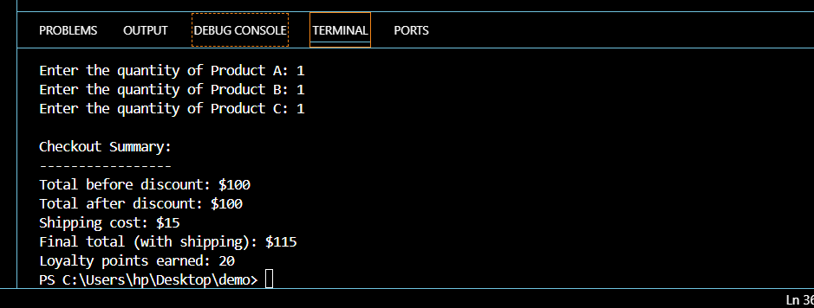

**Additional Tasks for the Basic E-Commerce Application**

**Task 1**

#include <iostream>

int main() {

    double priceA = 50.0, priceB = 30.0, priceC = 20.0;

    int quantityA, quantityB, quantityC;

    int paymentMethod;

    std::cout << "Enter quantity of product A: ";

    std::cin >> quantityA;

    std::cout << "Enter quantity of product B: ";

    std::cin >> quantityB;

    std::cout << "Enter quantity of product C: ";

    std::cin >> quantityC;

    double subtotal = (priceA * quantityA) + (priceB * quantityB) + (priceC * quantityC);

    double discount = (subtotal > 100.0) ? subtotal * 0.1 : 0.0;

    double totalAfterDiscount = subtotal - discount;

    double shipping = (totalAfterDiscount > 50.0) ? 0.0 : 5.0;

    double totalWithShipping = totalAfterDiscount + shipping;

    std::cout << "Select a payment method (1 for Credit Card, 2 for PayPal, 3 for Cash): ";

    std::cin >> paymentMethod;

    double transactionFee = (paymentMethod == 1) ? totalWithShipping * 0.02 :

                            (paymentMethod == 2) ? totalWithShipping * 0.03 : 0.0;

    double totalAfterPayment = totalWithShipping + transactionFee;

    std::cout << "Subtotal: $" << subtotal << std::endl;

    std::cout << "Discount: -$" << discount << std::endl;

    std::cout << "Shipping: $" << shipping << std::endl;

    std::cout << "Transaction fee: $" << transactionFee << std::endl;

    std::cout << "Total after applying transaction fee: $" << totalAfterPayment << std::endl;

    return 0;

}

Out put

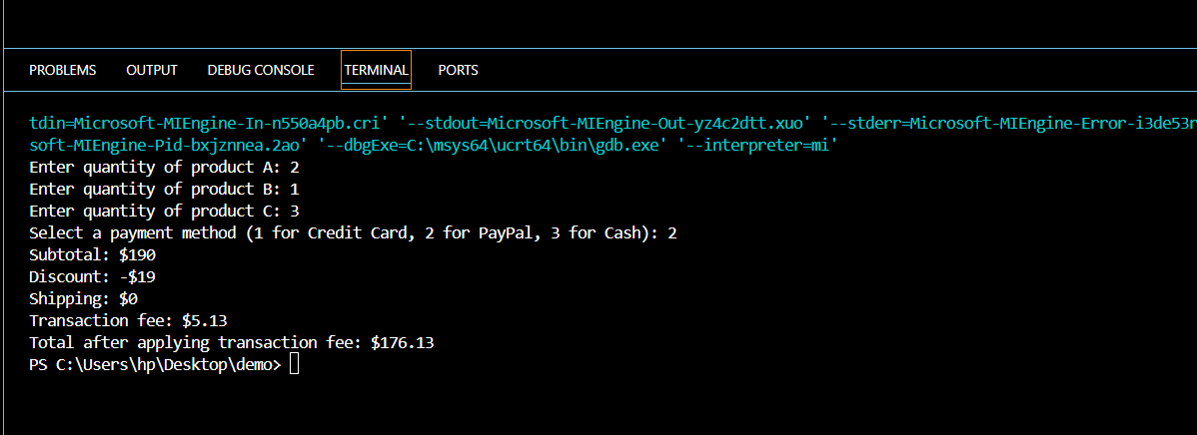

Task 2

#include <iostream>

int main() {

    double priceA = 50.0, priceB = 30.0, priceC = 20.0;

    int quantityA, quantityB, quantityC;

    int paymentMethod, customerType;

    std::cout << "Enter quantity of product A: ";

    std::cin >> quantityA;

    std::cout << "Enter quantity of product B: ";

    std::cin >> quantityB;

    std::cout << "Enter quantity of product C: ";

    std::cin >> quantityC;

    double subtotal = (priceA * quantityA) + (priceB * quantityB) + (priceC * quantityC);

    double discount = (subtotal > 100.0) ? subtotal * 0.1 : 0.0;

    double totalAfterDiscount = subtotal - discount;

    double shipping = (totalAfterDiscount > 50.0) ? 0.0 : 5.0;

    double totalWithShipping = totalAfterDiscount + shipping;

    std::cout << "Select a payment method (1 for Credit Card, 2 for PayPal, 3 for Cash): ";

    std::cin >> paymentMethod;

    double transactionFee = (paymentMethod == 1) ? totalWithShipping * 0.02 :

                            (paymentMethod == 2) ? totalWithShipping * 0.03 : 0.0;

    double totalAfterPayment = totalWithShipping + transactionFee;

    std::cout << "Enter customer type (1 for Regular, 2 for VIP): ";

    std::cin >> customerType;

    double finalAmount = (customerType == 2) ? totalAfterPayment * 0.95 : totalAfterPayment;

    std::cout << "Subtotal: $" << subtotal << std::endl;

    std::cout << "Discount: -$" << discount << std::endl;

    std::cout << "Shipping: $" << shipping << std::endl;

    std::cout << "Transaction fee: $" << transactionFee << std::endl;

    std::cout << "Customer discount: -$" << (customerType == 2 ? totalAfterPayment * 0.05 : 0.0) << std::endl;

    std::cout << "Final total: $" << finalAmount << std::endl;

    return 0;

}

Output

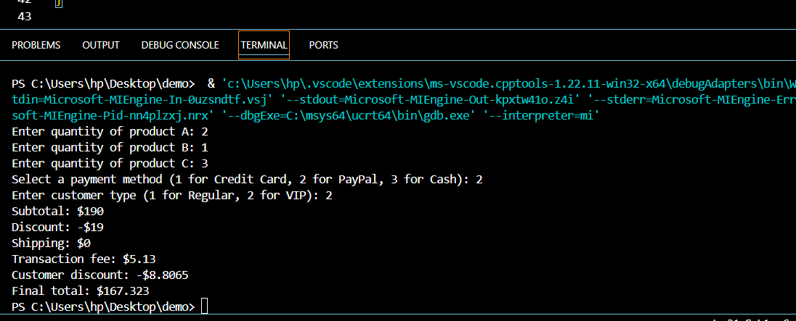

Task 3

#include <iostream>

#include <string>

int main() {

    double priceA = 50.0, priceB = 30.0, priceC = 20.0;

    int quantityA, quantityB, quantityC;

    int paymentMethod, customerType;

    std::cout << "Enter quantity of product A: ";

    std::cin >> quantityA;

    std::cout << "Enter quantity of product B: ";

    std::cin >> quantityB;

    std::cout << "Enter quantity of product C: ";

    std::cin >> quantityC;

    double subtotal = (priceA * quantityA) + (priceB * quantityB) + (priceC * quantityC);

    double discount = (subtotal > 100.0) ? subtotal * 0.1 : 0.0;

    double totalAfterDiscount = subtotal - discount;

    double shipping = (totalAfterDiscount > 50.0) ? 0.0 : 5.0;

    double totalWithShipping = totalAfterDiscount + shipping;

    std::cout << "Select a payment method (1 for Credit Card, 2 for PayPal, 3 for Cash): ";

    std::cin >> paymentMethod;

    double transactionFee = (paymentMethod == 1) ? totalWithShipping * 0.02 :

                            (paymentMethod == 2) ? totalWithShipping * 0.03 : 0.0;

    double totalAfterPayment = totalWithShipping + transactionFee;

    std::cout << "Enter customer type (1 for Regular, 2 for VIP): ";

    std::cin >> customerType;

    double finalAmount = (customerType == 2) ? totalAfterPayment * 0.95 : totalAfterPayment;

    std::string couponCode;

    std::cout << "Enter a coupon code (if any): ";

    std::cin >> couponCode;

    double couponDiscount = (couponCode == "SAVE10") ? 10.0 : 0.0;

    double totalAfterCoupon = finalAmount - couponDiscount;

    std::cout << "Subtotal: $" << subtotal << std::endl;

    std::cout << "Discount: -$" << discount << std::endl;

    std::cout << "Shipping: $" << shipping << std::endl;

    std::cout << "Transaction fee: $" << transactionFee << std::endl;

    std::cout << "Customer discount: -$" << (customerType == 2 ? totalAfterPayment * 0.05 : 0.0) << std::endl;

    std::cout << "Coupon discount: -$" << couponDiscount << std::endl;

    std::cout << "Final total: $" << totalAfterCoupon << std::endl;

    return 0;

}

Output

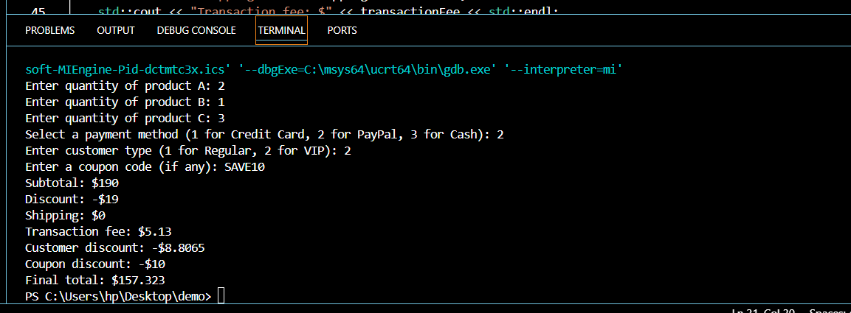

Task 4

#include <iostream>

#include <string>

int main() {

    double priceA = 50.0, priceB = 30.0, priceC = 20.0;

    int quantityA, quantityB, quantityC;

    int paymentMethod, customerType, location;

    std::cout << "Enter quantity of product A: ";

    std::cin >> quantityA;

    std::cout << "Enter quantity of product B: ";

    std::cin >> quantityB;

    std::cout << "Enter quantity of product C: ";

    std::cin >> quantityC;

    double subtotal = (priceA * quantityA) + (priceB * quantityB) + (priceC * quantityC);

    double discount = (subtotal > 100.0) ? subtotal * 0.1 : 0.0;

    double totalAfterDiscount = subtotal - discount;

    double shipping = (totalAfterDiscount > 50.0) ? 0.0 : 5.0;

    double totalWithShipping = totalAfterDiscount + shipping;

    std::cout << "Select a payment method (1 for Credit Card, 2 for PayPal, 3 for Cash): ";

    std::cin >> paymentMethod;

    double transactionFee = (paymentMethod == 1) ? totalWithShipping * 0.02 :

                            (paymentMethod == 2) ? totalWithShipping * 0.03 : 0.0;

    double totalAfterPayment = totalWithShipping + transactionFee;

    std::cout << "Enter customer type (1 for Regular, 2 for VIP): ";

    std::cin >> customerType;

    double finalAmount = (customerType == 2) ? totalAfterPayment * 0.95 : totalAfterPayment;

    std::string couponCode;

    std::cout << "Enter a coupon code (if any): ";

    std::cin >> couponCode;

    double couponDiscount = (couponCode == "SAVE10") ? 10.0 : 0.0;

    double totalAfterCoupon = finalAmount - couponDiscount;

    std::cout << "Enter your location (1, 2, or 3): ";

    std::cin >> location;

    double taxRate = (location == 1) ? 0.05 :

                     (location == 2) ? 0.10 : 0.08;

    double totalWithTax = totalAfterCoupon * (1 + taxRate);

    std::cout << "Subtotal: $" << subtotal << std::endl;

    std::cout << "Discount: -$" << discount << std::endl;

    std::cout << "Shipping: $" << shipping << std::endl;

    std::cout << "Transaction fee: $" << transactionFee << std::endl;

    std::cout << "Customer discount: -$" << (customerType == 2 ? totalAfterPayment * 0.05 : 0.0) << std::endl;

    std::cout << "Coupon discount: -$" << couponDiscount << std::endl;

    std::cout << "Sales tax: $" << (totalAfterCoupon * taxRate) << std::endl;

    std::cout << "Final total after tax: $" << totalWithTax << std::endl;

    return 0;

}

Out put

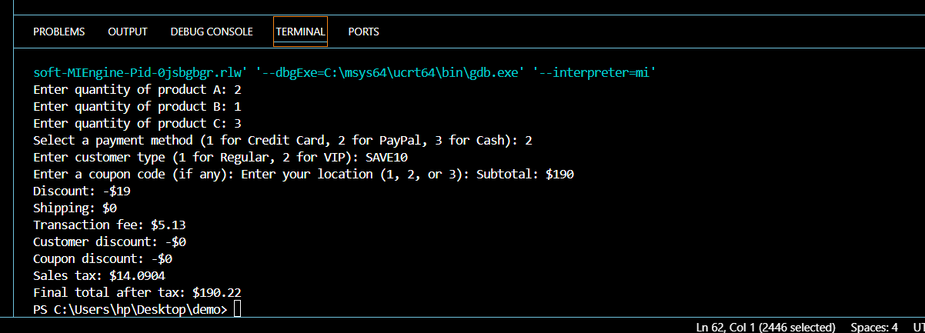

Task 5

#include <iostream>

#include <iomanip>

#include <string>

int main() {

    double priceA = 50.0, priceB = 30.0, priceC = 20.0;

    int quantityA, quantityB, quantityC;

    int paymentMethod, customerType, location;

    // Input quantities

    std::cout << "Enter quantity of product A: ";

    std::cin >> quantityA;

    std::cout << "Enter quantity of product B: ";

    std::cin >> quantityB;

    std::cout << "Enter quantity of product C: ";

    std::cin >> quantityC;

    double subtotal = (priceA * quantityA) + (priceB * quantityB) + (priceC * quantityC);

    double discount = (subtotal > 100.0) ? subtotal * 0.1 : 0.0;

    double totalAfterDiscount = subtotal - discount;

    double shipping = (totalAfterDiscount > 50.0) ? 0.0 : 5.0;

    double totalWithShipping = totalAfterDiscount + shipping;

    std::cout << "Select a payment method (1 for Credit Card, 2 for PayPal, 3 for Cash): ";

    std::cin >> paymentMethod;

    double transactionFee = (paymentMethod == 1) ? totalWithShipping * 0.02 :

                            (paymentMethod == 2) ? totalWithShipping * 0.03 : 0.0;

    double totalAfterPayment = totalWithShipping + transactionFee;

    std::cout << "Enter customer type (1 for Regular, 2 for VIP): ";

    std::cin >> customerType;

    double finalAmount = (customerType == 2) ? totalAfterPayment * 0.95 : totalAfterPayment;

    std::string couponCode;

    std::cout << "Enter a coupon code (if any): ";

    std::cin >> couponCode;

    double couponDiscount = (couponCode == "SAVE10") ? 10.0 : 0.0;

    double totalAfterCoupon = finalAmount - couponDiscount;

    std::cout << "Enter your location (1, 2, or 3): ";

    std::cin >> location;

    double taxRate = (location == 1) ? 0.05 :

                     (location == 2) ? 0.10 : 0.08;

    double totalWithTax = totalAfterCoupon * (1 + taxRate);

    std::cout << "\nOrder Summary:\n";

    std::cout << "----------------------------------------\n";

    std::cout << "Product A (x" << quantityA << "): $" << std::fixed << std::setprecision(2) << priceA * quantityA << std::endl;

    std::cout << "Product B (x" << quantityB << "): $" << priceB * quantityB << std::endl;

    std::cout << "Product C (x" << quantityC << "): $" << priceC * quantityC << std::endl;

    std::cout << "----------------------------------------\n";

    std::cout << "Subtotal: $" << subtotal << std::endl;

    std::cout << "Discount: -$" << discount << std::endl;

    std::cout << "Shipping: $" << shipping << std::endl;

    std::cout << "Transaction Fee: $" << transactionFee << std::endl;

    std::cout << "Coupon Discount: -$" << couponDiscount << std::endl;

    std::cout << "Sales Tax: $" << (totalWithTax - totalAfterCoupon) << std::endl;

    std::cout << "----------------------------------------\n";

    std::cout << "Final Total: $" << totalWithTax << std::endl;

    return 0;

}

OUTPUT

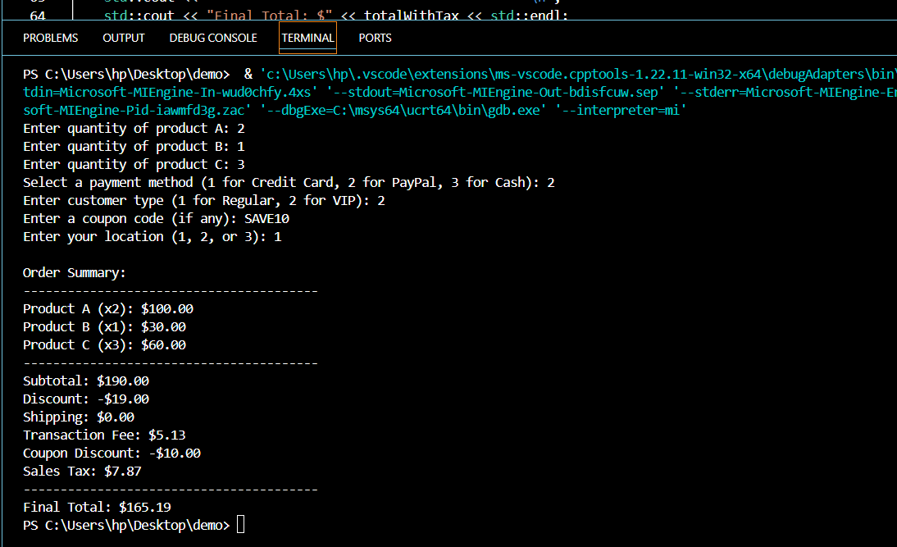

Task 6

#include <iostream>

#include <iomanip>

#include <string>

int main() {

    double priceA = 50.0, priceB = 30.0, priceC = 20.0;

    int stockA = 10, stockB = 5, stockC = 8;

    int quantityA, quantityB, quantityC;

    int paymentMethod, customerType, location;

    std::cout << "Enter quantity of Product A (max " << stockA << "): ";

    std::cin >> quantityA;

    if (quantityA > stockA) {

        std::cout << "Sorry, only " << stockA << " units of Product A are available.\n";

        quantityA = stockA;

    }

    std::cout << "Enter quantity of Product B (max " << stockB << "): ";

    std::cin >> quantityB;

    if (quantityB > stockB) {

        std::cout << "Sorry, only " << stockB << " units of Product B are available.\n";

        quantityB = stockB;

    }

    std::cout << "Enter quantity of Product C (max " << stockC << "): ";

    std::cin >> quantityC;

    if (quantityC > stockC) {

        std::cout << "Sorry, only " << stockC << " units of Product C are available.\n";

        quantityC = stockC;

    }

    double subtotal = (priceA * quantityA) + (priceB * quantityB) + (priceC * quantityC);

    double discount = (subtotal > 100.0) ? subtotal * 0.1 : 0.0;

    double totalAfterDiscount = subtotal - discount;

    double shipping = (totalAfterDiscount > 50.0) ? 0.0 : 5.0;

    double totalWithShipping = totalAfterDiscount + shipping;

    std::cout << "Select a payment method (1 for Credit Card, 2 for PayPal, 3 for Cash): ";

    std::cin >> paymentMethod;

    double transactionFee = (paymentMethod == 1) ? totalWithShipping * 0.02 :

                            (paymentMethod == 2) ? totalWithShipping * 0.03 : 0.0;

    double totalAfterPayment = totalWithShipping + transactionFee;

    std::cout << "Enter customer type (1 for Regular, 2 for VIP): ";

    std::cin >> customerType;

    double finalAmount = (customerType == 2) ? totalAfterPayment * 0.95 : totalAfterPayment;

    std::string couponCode;

    std::cout << "Enter a coupon code (if any): ";

    std::cin >> couponCode;

    double couponDiscount = (couponCode == "SAVE10") ? 10.0 : 0.0;

    double totalAfterCoupon = finalAmount - couponDiscount;

    std::cout << "Enter your location (1, 2, or 3): ";

    std::cin >> location;

    double taxRate = (location == 1) ? 0.05 :

                     (location == 2) ? 0.10 : 0.08;

    double totalWithTax = totalAfterCoupon * (1 + taxRate);

    std::cout << "\nOrder Summary:\n";

    std::cout << "----------------------------------------\n";

    std::cout << "Product A (x" << quantityA << "): $" << std::fixed << std::setprecision(2) << priceA * quantityA << std::endl;

    std::cout << "Product B (x" << quantityB << "): $" << priceB * quantityB << std::endl;

    std::cout << "Product C (x" << quantityC << "): $" << priceC * quantityC << std::endl;

    std::cout << "----------------------------------------\n";

    std::cout << "Subtotal: $" << subtotal << std::endl;

    std::cout << "Discount: -$" << discount << std::endl;

    std::cout << "Shipping: $" << shipping << std::endl;

    std::cout << "Transaction Fee: $" << transactionFee << std::endl;

    std::cout << "Coupon Discount: -$" << couponDiscount << std::endl;

    std::cout << "Sales Tax: $" << (totalWithTax - totalAfterCoupon) << std::endl;

    std::cout << "----------------------------------------\n";

    std::cout << "Final Total: $" << totalWithTax << std::endl;

    return 0;

}

Output

